Learning Documentation
Data Analysis Project
Title: [ ]
Name: Ngo Kim Truc
Date: 2025 / 10 / 20
Location: South Korea
(Not The Version That I Share With My Stakeholders)
- Ask
Questions -> metrics > data
Business requirements: . It represents a list of private companies with a value of over $1 billion as of March 2022. The data includes the name of the country where the company was founded, its current valuation, funding, industry, top investors, year it was founded, and the year it reached a $1 billion valuation. You will use this information to gain insights into how and when companies reach this prestigious milestone and to make recommendations for next steps to the investing firm.
- Identify the main industries that the investing firm is interested in investing in.
- Select a subset of this data that includes only companies in those industries.
- Analyze that subset more closely. Determine which companies have higher valuation but do not have as many investors currently. They may be good candidates to consider investing in.

- Prepare (data source)
https://www.coursera.org/learn/go-beyond-the-numbers-translate-data-into-insight/ungradedLab/k4GyE/activity-discover-what-is-in-your-dataset
https://www.kaggle.com/datasets/mysarahmadbhat/unicorn-companies
Why you use the tool, what is for?
Focus on business metrics
So what is the impact of your work to the company
North star metrics and dimensions (map the data variables in your dataset to the metrics that you already have identified in the first section, any metric is lacking?)
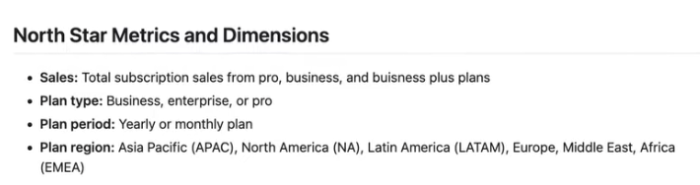

- Process (cleaning)
sql and export to tables
- I created a data profile using a self-taught prompt that I have revised every now and then when experiencing with new dataset. As this procedure is repetitive, I have decided to use AI for this to save time to conduct more insightful analysis

- Analyze (visualization in tableau)
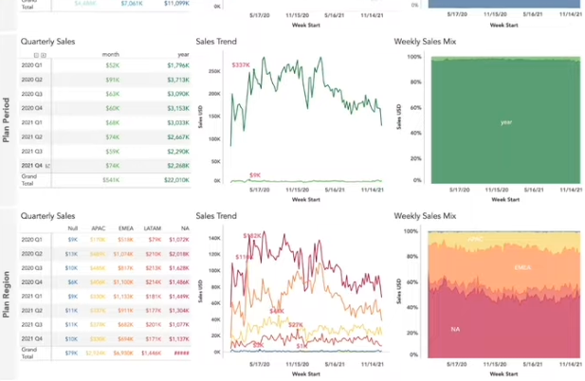
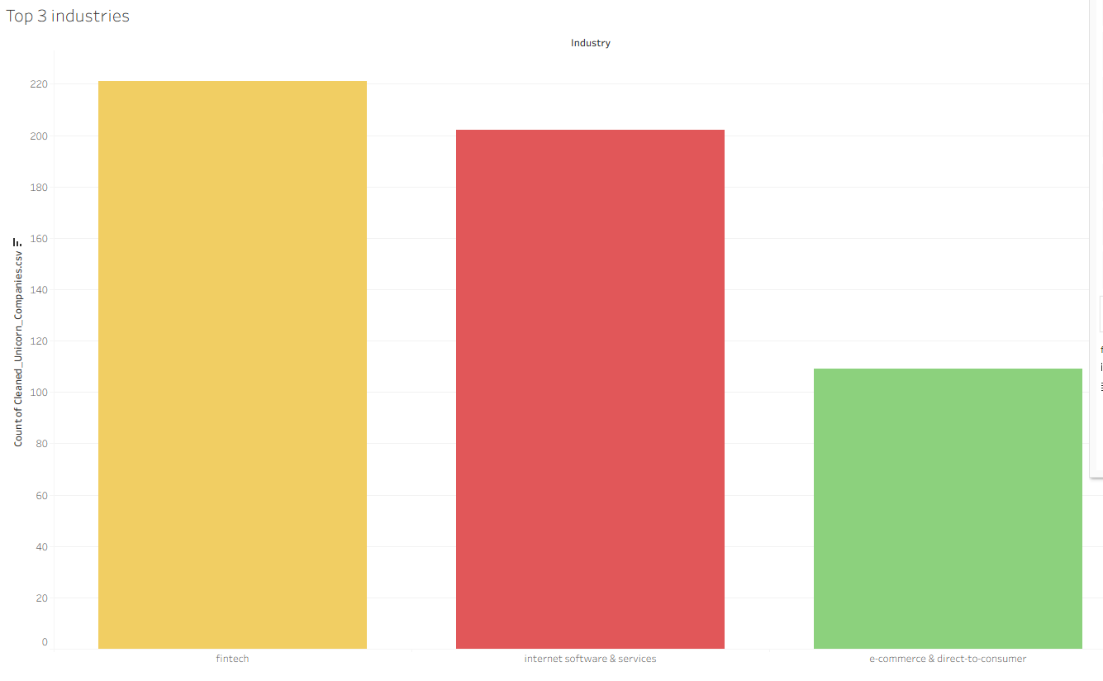
This reveals that the sectors that investors should invest in right now is fintech, internet software and services, ecommerce and direct-to-consumer. These sectors have produced the most unicorns in our dataset, showing the probability of producing more future unicorns
summary of insights

- Share
- Act
Recommendations and next steps
Show how you can collaborate: Work with the product and sales team to understand why there is a dip in this… over the last 3 months

- What to write in resume:
- Conducted analysis in SQL to surface insights on sales trends and SaaS metrics for a self-created Zoom dataset containing 100k subscription records.
- Worked independently for three weeks to clean and analyze data in SQL and built
- performance dashboard in Tableau to visualize trends related to plan types, regions, and plan periods.
- Surface insights and recommendations geared towards sales and marketing teams focusing on monthly promotions and enterprise plans.

